2nd open meeting of the COST Action CA19114
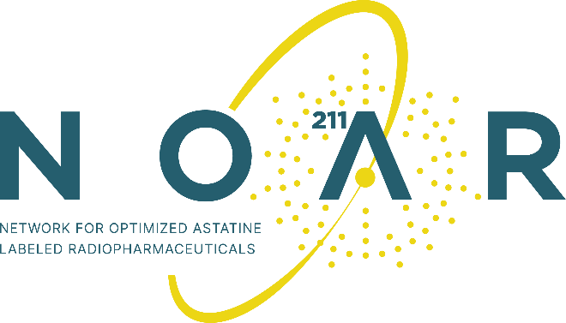
9th-11th of May 2023, Coimbra, Portugal,
University of Coimbra
Meeting Registration form

Name:
E-mail:
Affiliation:
Country:
☐ I am a junior researcher (PhD student, post-doc or similar)
☐ I am NOT eligible for reimbursement from COST (non-member, company representative etc.) or do not wish to be reimbursed. Non-members have a registration fee of 120€.
I would like to participate on:
Tuesday 9th May
☐ 18:00 – 22:00: Welcome lecture and reception (Science Museum)
Wednesday 10th May
☒ 09:00 – 17:00: Meeting Day 1 (Quinta das Lágrimas)
☐ 19:30: Gala Dinner (42€)
Thursday 11th May
☒ 09:00 – 15:00: Meeting Day 2 (Quinta das Lágrimas)
☐ 16:00: Visit to University (8€)

Reception on the 9th of May and working lunches on the 10th and 11th are included. Gala Dinner on the 10th and Visit to University on the 11th are extra and can be paid at the site but need to be indicated here to insure availability. Places for the University visit are limited. Additional tickets will be available for Friday 12th in the morning, if required. There is also the possibility to visit the garden of Quinta das Lágrimas. This can be booked at the site (7.50€).
Please send the filled form to icnas@uc.pt by April 7th at the latest.

